Module 3 : Basic Charts in Tableau

1. Text Table: Create a Text Table that displays profit as a function of Product Sub-Category and Year. Represent the data as Percentage of each cell with respect to the entire table. Display the grand Totals for Rows and Columns. Explain your interpretation of the data.

Sample Output Screen shot:

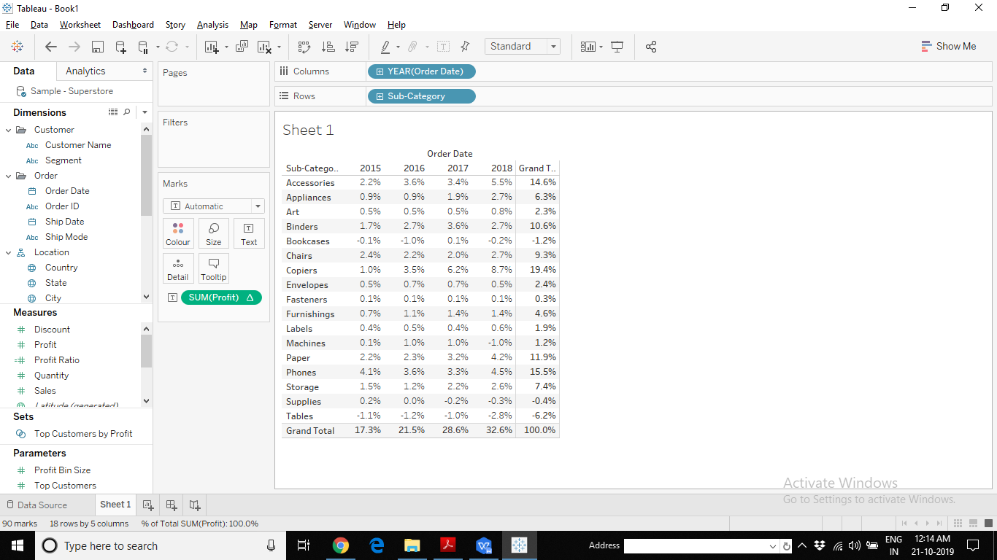

1. Highlight Table: Create a Highlight Table the displays the Sales, Profit, Discount and Quantity for all the Sub-Categories. Highlight the data based on the respective Measure Value. Use different colours for different measures to help understand the data easily.

Sample Output Screen shot:

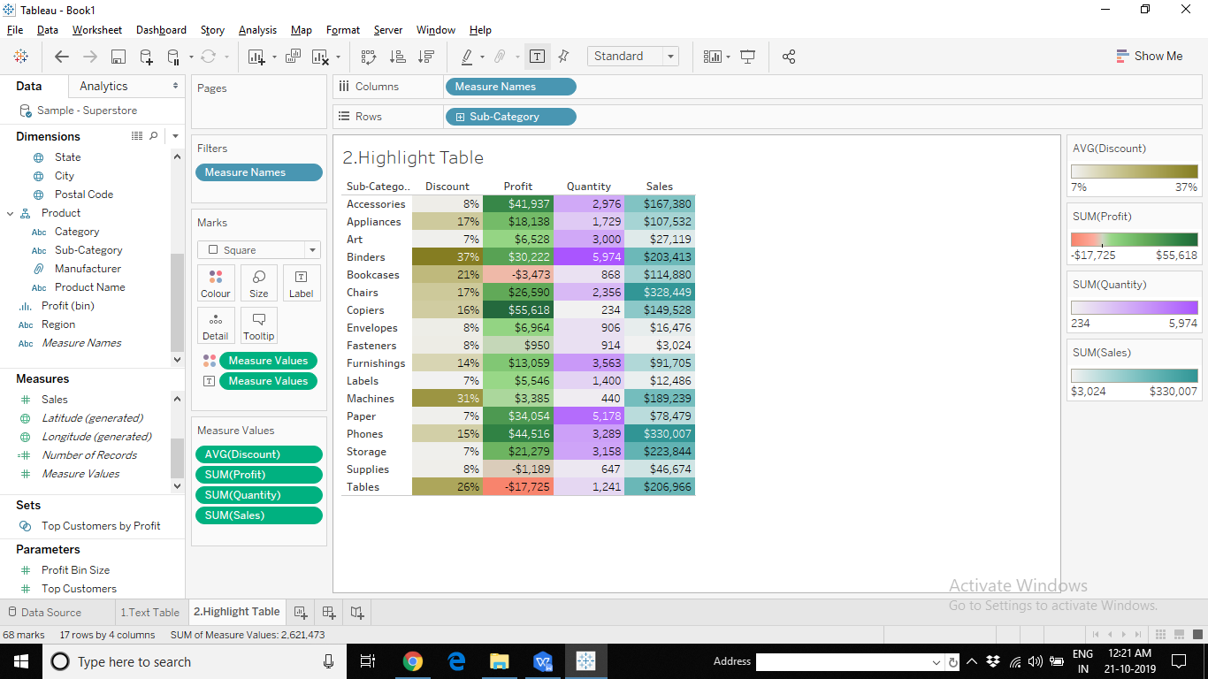

1. Pie Chart: Create a Pie Chart showing the Profits of Superstore for different Regions. Compare the pies across different Categories. Which Category has the highest Profit? Further, in the Category with highest profit, identify the region with highest profit.

Sample Output Screen shot:

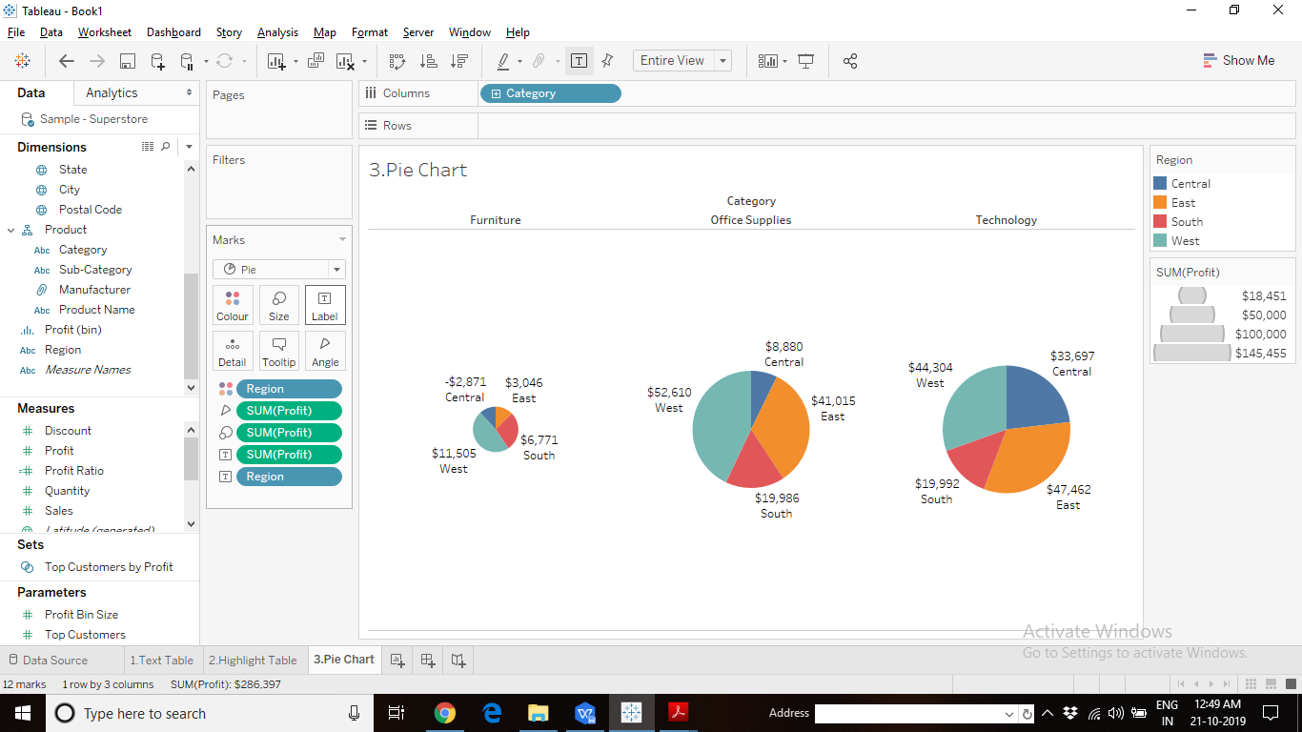

1. Bar Graph:The Regional Sales Managers of Coffee Chain is interested in an analysis of profit by product. They will use this data to discuss the possible pricing changes and product cancellations. Create a Bar graph to help in this analysis.

Hint: Use Coffee Chain Data. Create a calculated field to check (profit - Budget Profit). Use this field to colour the Bars.

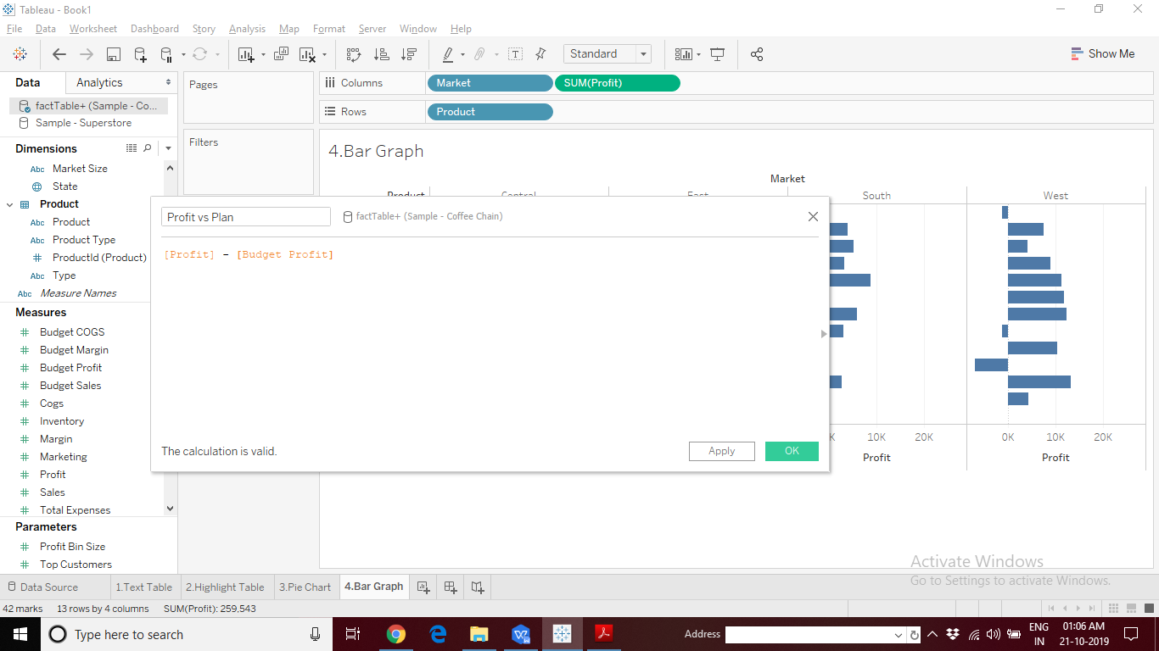

Sample Output Screen shot:

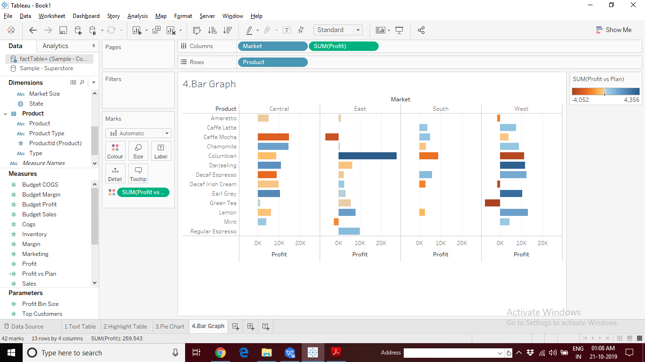

1. Bar Graph: Regional Managers of Coffee Chain want to perform Profit Spotlighting. Indicate the products with profits greater than $10,000 in Green colour, profit below $1000 in Red Colour and rest of the products in Grey Colour. Use Conditional formatting to accomplish this.

Sample Output Screen shot:

